**Macintosh HD:Users:rruzzo:Desktop:logo.pngCapstone Analytics**

User’s Manual

Version 1.0

Table of Contents

1 Introduction 4

1.1 Purpose 4

2 General Web Page Layout 4

2.1 Overview Pre Login 4

2.2 Login 5

2.3 Overview Post Login 6

2.4 Log Out 6

Clicking the hyper link “Log Out” will automatically sign out the account user. To log back in click the “Log In” hyperlink on the left navigation bar. 6

2.5 My Account 6

2.6 Shop Batting 7

3 Shop Batting Searches 7

3.1 Statistic Drop Down Menu 7

3.1.1 Hits 8

A hit, is credited to a batter when the batter safely reaches first base after hitting the ball into fair territory, without the benefit of an error or a fielder's choice. This can be used to measure a batter’s consistency. 8

3.1.3 Doubles 8

A double is the act of a batter striking the pitched ball and safely reaching second base without being called out by the umpire, without the benefit of a fielder's misplay or another runner being put out on a fielder's choice. This can be used to measure both speed and consistency of a batter. 8

3.1.4 Homerun 8

A home run is scored when the ball is hit in such a way that the batter is able to circle the bases and reach home safely in one play without any errors being committed by the defensive team in the process. This can be used to measure a batter’s power. 8

3.1.5 Minimum At Bats Drop 9

3.1.6 Fielding 9

3.1.7 Pitching 9

3.2 Minimum at Bats Drop Down Menu 9

3.2.1 0 at Bats 9

3.2.2 162 at Bats 10

3.2.2 502 at Bats 10

3.3 Maximum Birth Year Drop Down Menu 10

3.3 Search Players 10

4 Shop Batting Results 11

4.1 General 11

4.1.2 Player 11

4.1.3 Count 11

4.1.4 Salary 11

4.1.5 Expected Salary 11

4.1.5 Salary Difference 12

# 1 Introduction

## 1.1 Purpose

Capstone Analytics uses annual statistics and salaries to use statistical analysis to determine the fair market value of a player. Based on that statistical analysis players that are underpaid based on performance would be identified as optimal candidates for acquisition. Conversely overpaid players could be avoided. Ultimately use these tools to maximize profits by avoiding bad contracts.

# 2 General Web Page Layout

## 2.1 Overview Pre Login

This is the homepage of [www.sportssalaryanalytics.com](http://www.sportssalaryanalytics.com) and it serves as the gateway into capstone analytics. On the left navigation bar the user will see a navigation bar with the Log In and Overview. Use the Login page to enter the rest of the website.

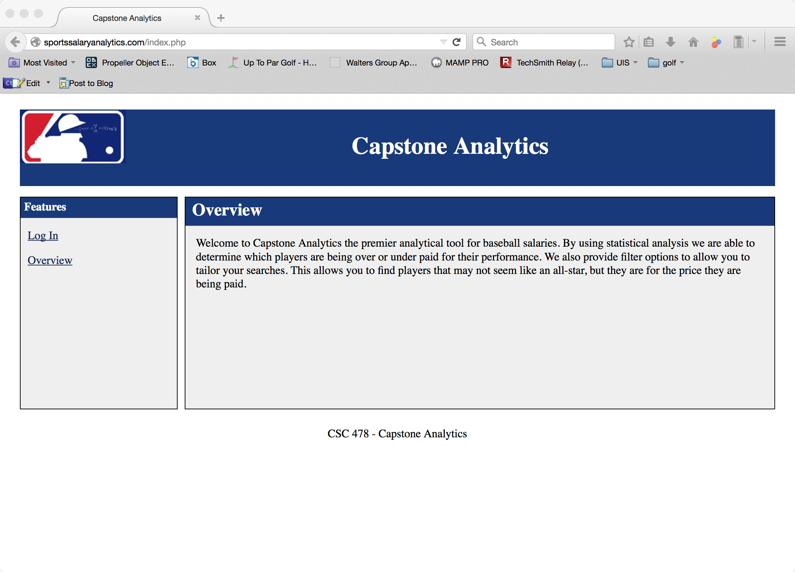

## 2.2 Login

There are two data fields on the Login Page, Username and Password. Username is the unique ID that was issued by subscription services. Password is the password that was issued by subscription services and may be changed later.

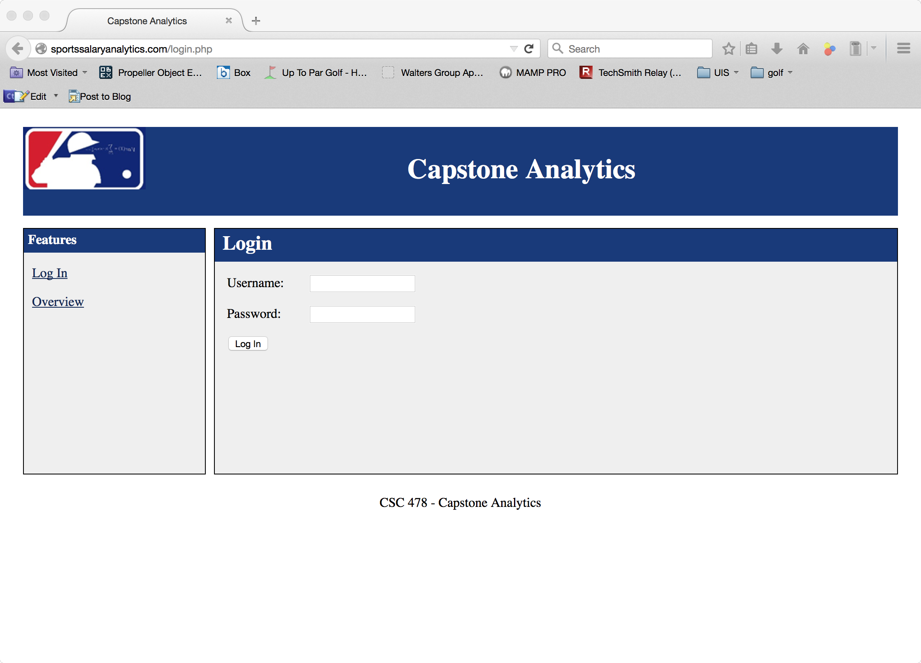

## 2.3 Overview Post Login

This is the homepage of [www.sportssalaryanalytics.com](http://www.sportssalaryanalytics.com) and it serves as the gateway into capstone analytics. On the left navigation bar the user will see an updated navigation bar with the Log Out, My Account, Overview and Shop Batting.

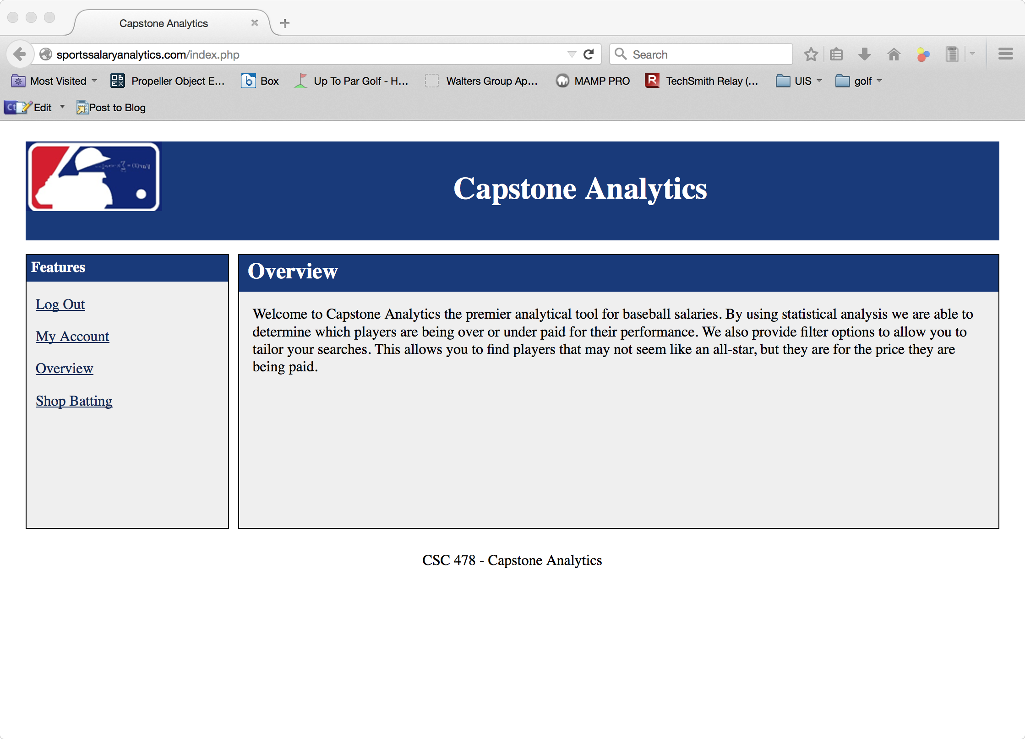

## 2.4 Log Out

## Clicking the hyper link “Log Out” will automatically sign out the account user. To log back in click the “Log In” hyperlink on the left navigation bar.

## 2.5 My Account

There are two data fields on the My Account Page, Old Password and New Password. Additionally there is a clickable update button below them. In order to update the password, the user must enter their current password in the “Old Password” field and their desired password in the “New Password” Field. The new password must be 8 characters at least one upper and lowercase letter, one number, and a special character (!@#$%^&*()_-+/\’:,?{}[]~).

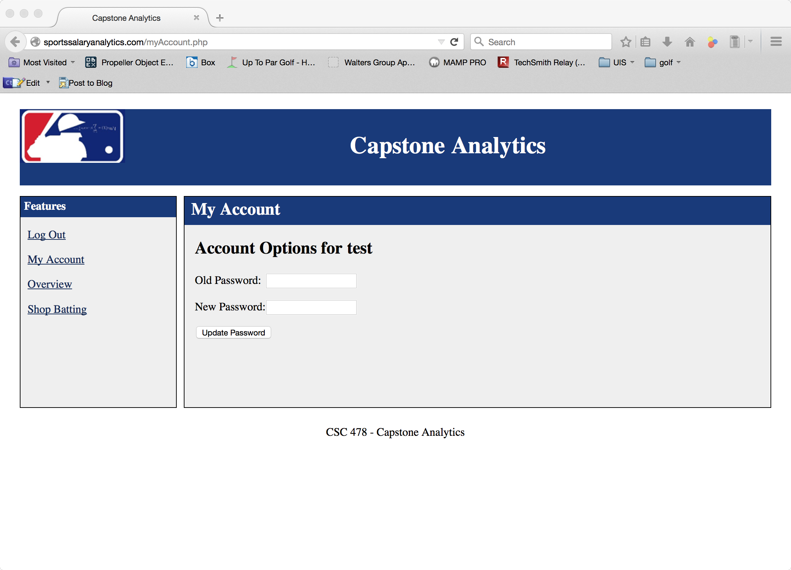

## 2.6 Shop Batting

Allow the user to perform statistical analysis on certain player populations.

# 3 Shop Batting Searches

## 3.1 Statistic Drop Down Menu

Provides three batting statistics (hits, doubles, homeruns) to choose from. This input along with player’s salaries will be used to perform a linear regression.

### Macintosh HD:Users:rruzzo:Desktop:Final Project:userManual:statsDropDown.tiff

### 3.1.1 Hits

### A hit, is credited to a batter when the batter safely reaches first base after hitting the ball into fair territory, without the benefit of an error or a fielder's choice. This can be used to measure a batter’s consistency.

### 3.1.3 Doubles

### A double is the act of a batter striking the pitched ball and safely reaching second base without being called out by the umpire, without the benefit of a fielder's misplay or another runner being put out on a fielder's choice. This can be used to measure both speed and consistency of a batter.

### 3.1.4 Homerun

### A home run is scored when the ball is hit in such a way that the batter is able to circle the bases and reach home safely in one play without any errors being committed by the defensive team in the process. This can be used to measure a batter’s power.

### 3.1.5 Minimum At Bats Drop

Batting will account for multiple member fields in the database and will contain multiple variables that are standard to baseball.

### 3.1.6 Fielding

Fielding will account for multiple member fields in the database and will contain multiple variables that are standard to baseball.

### 3.1.7 Pitching

Pitching will account for multiple member fields in the database and will contain multiple variables that are standard to baseball.

## 3.2 Minimum at Bats Drop Down Menu

Filters out players from analysis based upon at bats.

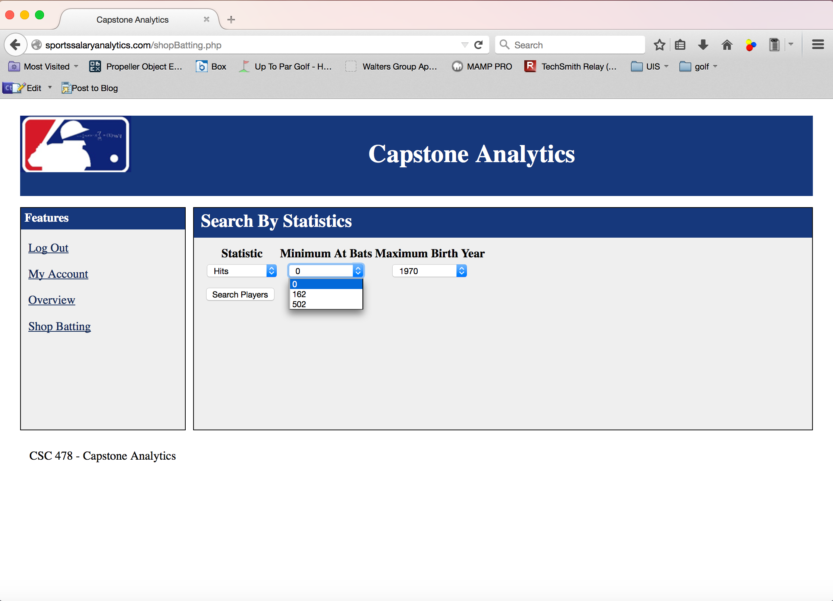

### 3.2.1 0 at Bats

All field players are part of the linear regression. This option can decrease positive correlation due to injured players or suspended players salary being calculated and not having an hit, doubles, or homeruns.

### 3.2.2 162 at Bats

162 at bats correlates to one at bat per game. This option accounts for journeyman players or non-starters that have a contribution that might be noteworthy in regards to their salary.

### 3.2.2 502 at Bats

502 at bats correlates to approximately three at bats per game. This option accounts for players that play more than 70-75% of all games.

## 3.3 Maximum Birth Year Drop Down Menu

Filters out players from analysis based upon year of birth. This option attempts to reduce the amount of players on a rookie contract in the sample population.

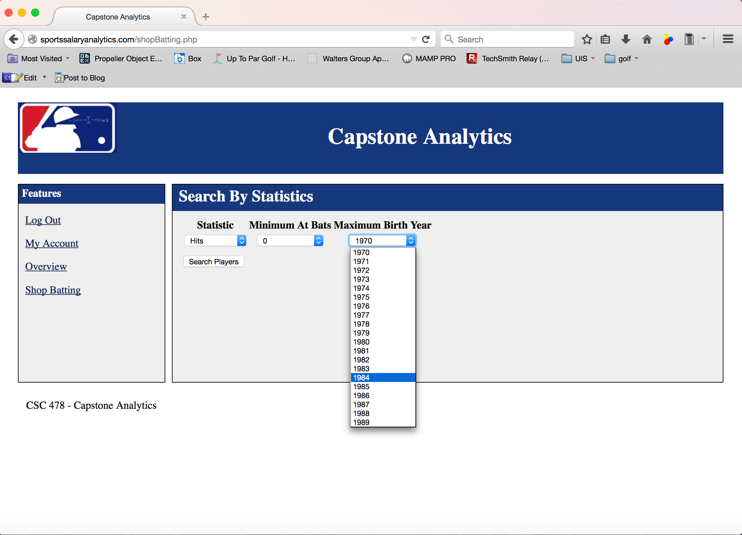

## 3.3 Search Players

The “Search Players” button starts the linear regression and displays the results based upon the selected search criteria.

# 4 Shop Batting Results

## 4.1 General

Shop Batting returns the “Top 50” players from the search criteria. The list of player is ordered by difference between the player’s salary and their fair market value or expected salary.

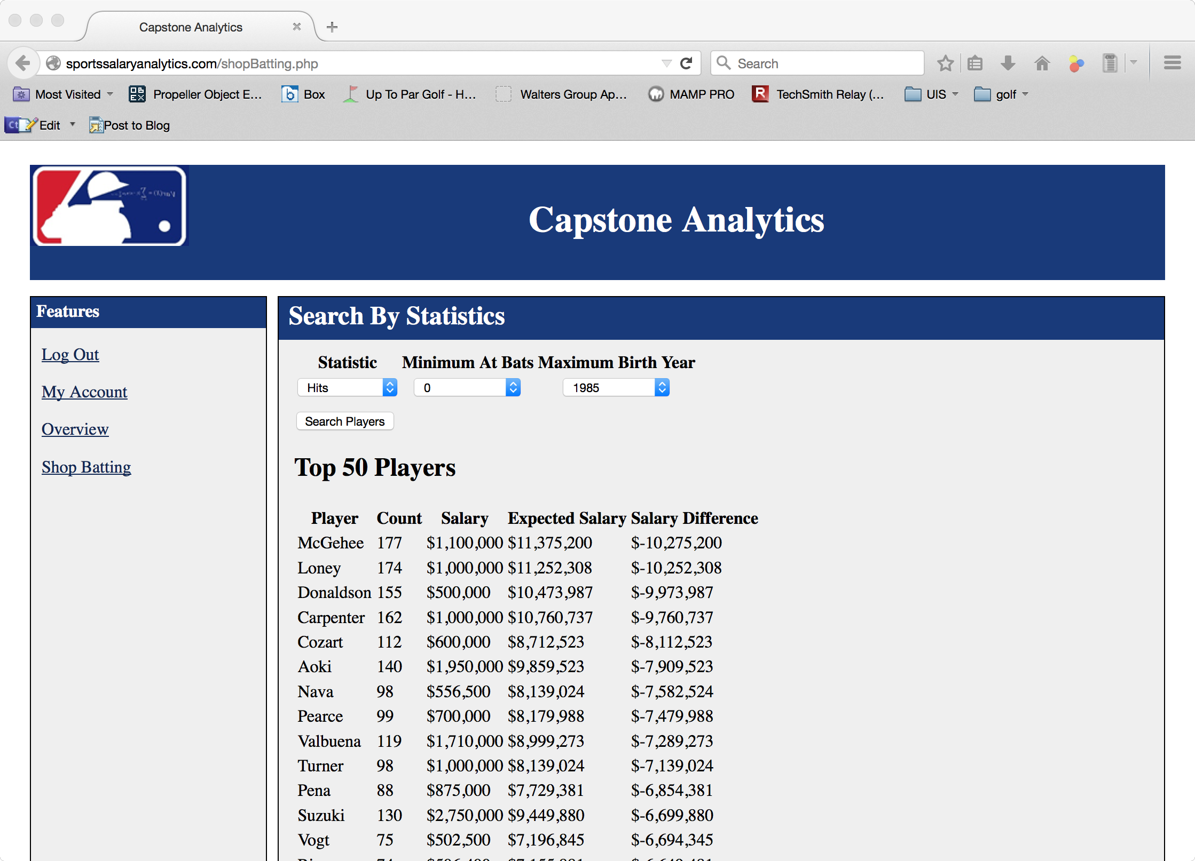

### 4.1.2 Player

Players are listed by last name.

### 4.1.3 Count

Count is the total of the chosen stat from the search criteria.

### 4.1.4 Salary

The salary value is the player’s salary from 2014.

### 4.1.5 Expected Salary

Expected salary is the fair market value based on linear regression.

### 4.1.5 Salary Difference

Salary Difference is the difference between a player’s 2014 salary and their fair market value or expected salary.

Salary – Expected Salary = Salary Difference.